Aperture Robotics

490 Seymour Ave.

Victoria, BC, V8N 2R4

(778) 998-3636

April 3rd, 2018

Dr. David Riddell

Director of Marine Technology Centre

Oceans Network Canada

University of Victoria

PO Box 3070, STN CSC,

Victoria, BC, V8W 3W1

Dear Dr. Riddell,

In response to RFP-VN120-2018, our team has designed three alternative prototype solutions and have attached them to this letter.

The enclosed recommendation report gives background information on the problem Ocean Networks Canada (ONC) is currently facing. Each robot is then explained in detail by outlining mechanical, electrical, and software functions. The pros and cons of each design is evaluated and compared to one another so that a concrete conclusion can be made. The report ends with the decision that the Magneto design should be fully realized by ONC.

Aperture Robotics greatly appreciates the opportunity to assist with solving ONCs problem. We anticipate feedback and if there are any concerns our team would be happy to assist. Thank you for considering our proposal and we seek your approval to continue production on the Magneto design.

Sincerely,

|  |  |
| --- | --- |
| C Buchko  Connor Buchko | Wasif  Mustafa Wasif |
| Evan Roubekas | AqeelMOzumder  Aqeel Mozumder |

Aperture Robotics

Attachment: Recommendation Repor



Recommendation Report

Connor Buchko - Evan Roubekas - Mustafa Wasif - Aqeel Mozumder

Ocean Networks Canada

Dr. Dave Riddell

RFP-VN120-2018

April 3rd, 2018

# Table of Contents

Table of Contents……………………………………………………………………………………………………………………………………………………… i

List of Figures and Tables……………..……………..……………..……………..……………..……………..……………..……………..………………. ii

Executive Summary……………..……………..……………..……………..……………..……………..……………..……………..………………………. iii

Glossary……………..……………..……………..……………..……………..……………..……………..……………..……………..………………………… iv

1. Introduction……………..……………..……………..……………..……………..……………..……………..……………..……………..………………. 1

1.1 Ocean Networks Canada……………..……………..……………..……………..……………..……………..……………..…………………….. 1

1.2 ONC’s Request……………..……………..……………..……………..……………..……………..……………..……………..…………………….. 1

2. Solution Alternatives……………..……………..……………..……………..……………..……………..……………..……………..…………………. 2

2.1 Omega……………..……………..……………..……………..……….……………..……………..……………..……………..……………..………… 2

2.1.1 Structure and Mechanism……………..……………..……………..……………..……………..……………..…………………………… 2

2.1.2 Sensors and Movement……………..……………..……………..……………..……………..……………..……………..……………….. 2

2.1.3 Programming design……………..……………..……………..……………..……………..……………..……………..……………………. 3

2.2 I.P.A. ……………..……………..……………..……………..……………..……………..……………..……………..……………..……………………. 3

2.2.1 Structure and Mechanism……………..……………..……………..……………..……………..……………..…………………………… 3

2.2.2 Sensors and Movement……………..……………..……………..……………..…………..……………..……………..……………….... 4

2.2.3 Programming design……………..……………..……………..……………..……………..……………..……………..……………………. 4

2.3 Magneto……………..……………..……………..……………..……………..……………..……………..……………..……………..………………. 5

2.3.1 Structure and Mechanism……………..……………..……………..……………..……………..……………..……………..……………. 5

2.3.2 Sensors and Movement……………..……………..……………..……………..……………..……………..……………..……………….. 5

2.3.3 Programming design……………..……………..……………..……………..……………..……………..……………..……………..……. 6

3. Comparative Evaluation……………..……………..……………..……………..……………..……………..……………..……………………………. 7

3.1 Reliability……………..……………..……………..……………..……………..……………..……………..……………..……………..…………….. 8

3.2 Maneuverability……………..……………..……………..……………..……………..……………..…………..……………..………………….... 8

3.3 Other Criteria……………..……………..……………..……………..……………..……………..……………..………………..……………………. 8

4. Conclusion……………..……………..……………..……………..……………..……………..……………..……………..……………..……………..….. 8

5. Recommendation……………..……………..……………..……………..……………..……………..……………..……………..……………..………. 9

6. References……………..……………..……………..……………..……………..……………..……………..……………..……………..……………….. 10

Appendices……………………………..……………..……………..……………..……………..……………..……………..……………..…………………. 11

Appendix A - Work Log……………..……………..……………..……………..……………..……………..……………..……………..……………. 11

Appendix B……………..……………..……………..……………..……………..……………..……………..……………..……………..………………. 12

i

# List of Figures and Tables

Figure 2.1.1……………..……………..……………..……………..……………..……………..……………………. 2

Figure 2.2.1……………..……………..……………..……………..……………..……………..……………..…...… 3

Figure 2.2.2……………..……………..……………..……………..……………..……………..……………………. 4

Figure 2.3.1……………..……………..……………..……………..……………..……………..……………………. 5

Figure 2.3.2……………..……………..……………..……………..……………..……………..……………………. 5

Table 3.0……………..……………..……………..……………..……………..……………..……………..………… 7

Table A……………..……………..……………..……………..……………..……………..……………..………… 11

# 

# 

# 

# 

# 

# 

# 

ii

# Executive Summary

This report provides an analysis and evaluation of three alternative prototype robots of Aperture Robotics and recommends to consider one of the robots . We outlined the specific needs, objectives and constraints as defined by Ocean Networks Canada (ONC). The descriptions and analysis of the three prototype robots, Omega (Figure 1.1), I.P.A (Figure 2.1) and Magneto (Figure 3.1), are discussed broadly in the Design section. The descriptions are broken down into structure and materials, movement and mechanisms and programming design. A weighted objective chart (Table 1.0) was used to compare the robots and select one robot on the basis of the results.

The scores calculated out of 10 were

* Omega - 6.45
* I.P.A - 6.36
* Magneto - 6.76

Based on these results, we would like to recommend ONC to consider revising the Magneto prototype for greater consistency in the cable connection mechanism and develop its existing features.

# 

# 

# 

# 

iii

# Glossary

iv

|  |  |
| --- | --- |
| **Beacon** | The general term used for the object that is where the cable connection occurs as well as where the infrared light is emitted. |
| **Infrared Light /**  **Infrared Radiation** | A type of light that cannot be seen with the human eye but can be detected through the use of sensors. |
| **Infrared Sensor / IR Sensor / Phototransistor** | The type of sensor used by the robot prototypes to detect infrared light. |
| **Microcontroller** | The central processing unit where the sensors and motors and connected to. This microcontroller is the programmable aspect of the robot. |
| **Ultrasonic Range Finder** | A sensor that uses sound waves to detect distances between two objects. |

# 1. Introduction

The goal of this report is to recommend a final prototype robot design to Ocean Networks Canada. Located in the report are the analysis of three robot designs, a comparative evaluation of the three designs, and finally the recommendation of one of the designs to Ocean Networks Canada.

## 1.1 Ocean Networks Canada

Ocean Networks Canada (ONC) is currently operating numerous underwater observatories with two notable observatories being NEPTUNE and VENUS. These observatories house sensors and underwater cameras that provide “unique scientific and technical capabilities that permit researchers to operate instruments remotely and receive data … anywhere on the globe in real time.” [1] Ocean Networks Canada can contribute data on the ocean floor, water quality, and biology using these observatories. The data collected is then sent to the shore via data cables that connect the observatories and sensors [1].

## 1.2 ONC’s Request

Due to the turbulent nature of the ocean the cables connecting observatories experience great wear and tear. As new cameras and sensors are installed new cable are also needed to connect them. Renting machinery and robots from other companies to repair the cables is unfeasible due to the costs. The process can also be accomplished by human operators but not without risk. In the efforts to find another solution Ocean Networks Canada has sent out a request for proposal asking for robot prototypes that would be able to make cable connections on the ocean floor [2]. The robot must be autonomous as undersea communication with the robots is difficult and tethers connecting the robot to the surface can occasionally be unreliable. Due to the sensitive nature of the ocean floor the robots design must also be conscious of environmental impacts and the robot should not cause any damage to its surroundings. The robot prototypes should have a small scale and will be tested on cable connection in dry conditions. The prototype has several tasks that must be completed autonomously and with minimal environmental impact

1. Find a “beacon” emitting infrared light
2. Approach the beacon carrying a cable
3. Make a cable connection to the beacon
4. Separate itself from the cable
5. Signal completion of the connection

1

The prototypes have a budget of $25 that can be used towards extra parts and sensors. The constraints taken into consideration when recommending a design were

|  |  |
| --- | --- |
| * Cost | * Maneuverability |
| * Simplicity of design | * Reliability |
| * Simplicity / readability of software | * Size |
| * Aesthetic | * Maintenance requirements |

# 2. Solution Alternatives

Three different design prototypes are described in the following section. Each design has its own benefits and solves the problem in a different way.

## 2.1 Omega

Omega is a simplistic box based robot that uses a lever mechanism to connect the cable.

### 2.1.1 Structure and Mechanism

Omegas box base and low centre of gravity allows it to turn and move with ease. Omegas middle has a tower protruding with a metal beam that acts as a lever. The materials required for Omega are all from the supplied VEX kit. This includes metal pieces, motors, wheels and gears. Omega has a specialized beacon for its unique connection mechanism. The beacon has a bowl on top that catches a block and magnets ensure that the cable stays connected as Omega reverses. The lever starts angled upwards, as seen in figure 1.1. When the mechanism is in range to attach, the lever drops. The block on the lever falls off into the bowl and attaches itself to the magnets. Omega lifts the lever back up and drives away, dropping the cable off to its side and leaving the object behind. 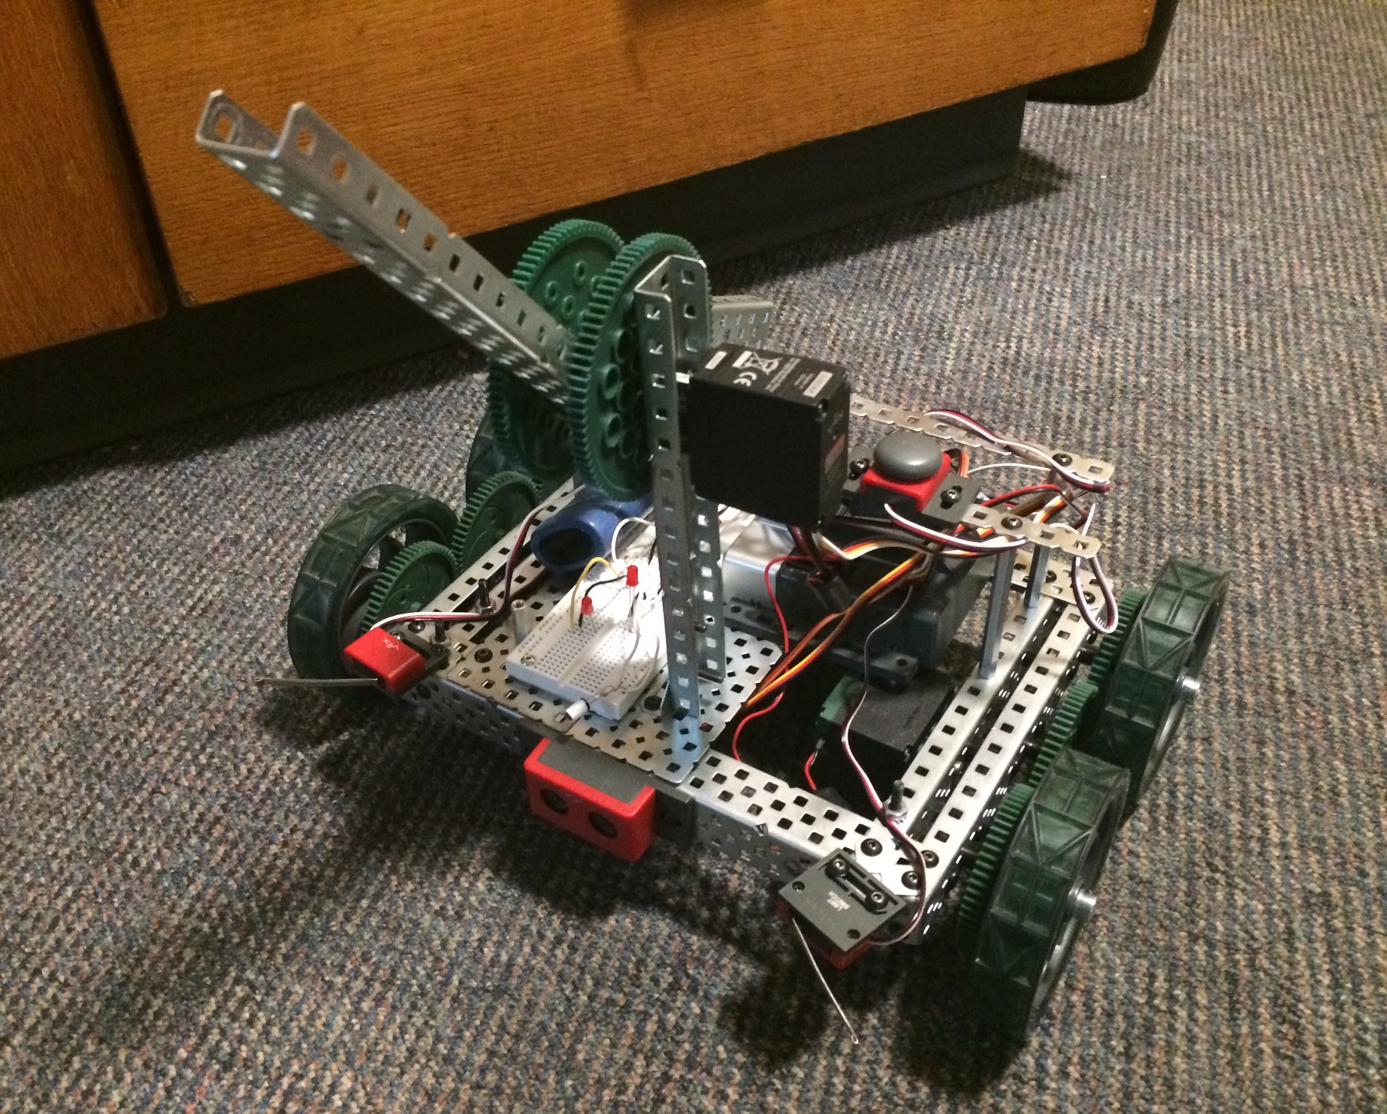

Figure 2.1.1 - Profile of the Robot

### 2.1.2 Sensors and Movement

Four wheels at the corners of the base assist with movement and rotation. Each pair of wheels shares a motor connected by three gears. The robot can turn 360 degrees on the spot without any problems. The robot detects the beacon with a front facing IR sensor. Whenever the IR sensor notices a large difference in the light level, it knows to stop searching. An ultrasonic range finder is used to detect distance. If Omega is facing the beacon, it can now exactly how far away it is due to the ultrasonic range finder. Additionally, two limit switches are located at Omegas

2

front ends. When the limit switches are pushed, Omega knows it has bumped into a wall and will correct accordingly.

### 2.1.3 Programming design

The code is elegantly written and accounts for all possible cases where Omega could encounter a problem. Two monitor light functions use two different thresholds to assist beacon detection. When Omega is far away from the beacon, the lower threshold is used which allows for greater detection range. When Omega is close to the beacon, the higher threshold is used instead which sacrifices range for precision. The second threshold is important because the IR light reflects off nearby walls which Omega must ignore. However, if we only utilized the second threshold, Omega would not be able to detect the beacon from far away. Another important part of the code is the scan function. When Omega scans, it makes sure to never turn a full 360 degrees. It always rotates to the left for a set time and then turns to the right the rest of the way. If Omega where to turn a full 360 degrees, the cable would tangle around the tall mechanism arm and the cable connection would fail.

## 2.2 I.P.A.

I.P.A. uses top of the line technology to approach the beacon using infrared and ultrasonic sensors to successfully connect the cable using its clever mechanism.

### 2.2.1 Structure and Mechanism

The combined structure and mechanism of I.P.A. make for a remarkably simple robot. As seen in figure 2.1 the structure consists of

* Lower platform holding the circuit board
* Upper platform which holds the microcontroller
* Mechanism connected to the robot via upper platform
* Motorized chassis that supplies the robot’s movement

Figure 2.2.1 - Side profile of the Robot

The mechanism works using two gears that effectively holds the cable while the robot approaches the connector. When the connector is in range the robot will approach and physically contact it while simultaneously spinning the gears to unwind the cable. With our robot’s design, contact with the end of the cable and the connector is enough to make a successful connection.

3

### 2.2.2 Sensors and Movement

The circuit board and sensors were a more involved process during the creation of the final prototype. The robot utilizes the circuit board, also known as a breadboard, for two uses. The first and more important purpose is to detect the infrared light. This is done using a phototransistor which can be seen poking out between the two screws on the far-left side of figure 2.2. When the phototransistor has detected a strong source of infrared light it sends a signal to the breadboard and microcontroller. The breadboard will then execute its second task which turns on the red LEDs that can be seen sticking out of the breadboard in figure 2.2. Only when a strong enough infrared source has been detected and the LEDs turn on will the robot move forward. The robot’s movement is controlled by two motors, one for each side of the robot. The motors can be controlled independently and spun in different directions so that the robot is able to move forward and backward as well as turn in any direction.

Figure 2.2.2 - Sensors and Breadboard

### 2.2.3 Programming design

The programming behind I.P.A. is simplistic in design as to avoid the possibility for bugs. When turned on, I.P.A. is programmed to spin clockwise until it detects an unreasonably high infrared light (IR) signature. When the IR light is detected I.P.A. is programmed to stop and move towards the light at a steady pace. Once the robot is within 35 centimeters it stops and spins again to detect the IR light a second time. Once the IR light is detected a second time the robot is programmed to do a distance check. If the robot detects the IR light and is not within 35 centimeters of an object it will begin to move forward again until it comes within 35 centimeters of something. Once the robot is within 35 centimeters of an object and the IR light is detected it executes the function that performs the series of actions that make up the mechanism. After the mechanism function executes and the cable is successfully connected the robot is programmed to stop moving and turn on an LED light that marks completion.

4

## 2.3 Magneto

Magneto is a medium-sized 4-wheel prototype robot that uses infrared radiation and sonar to approach towards the beacon and connects the cable with the help of magnets.

### 2.3.1 Structure and Mechanism

The structure of Magneto is built in such a way that the width of the robot is more and the height is of the robot is medium to have maximum stability. The lever is placed at left side, cortex at the middle and breadboard at the right side. The materials needed to built Magneto are all from the VEX kit. Magneto uses a lever mechanism to connect the magnet to a magnetic target which is above the beacon. The cable is tied with a magnet by a small clip and has a knot on a hook at the end of the lever. The robot approaches towards the beacon and with the help of sonar and limit switches the robot doesn’t crash with the beacon. When the lever rises, the magnetic target object will attract the magnet from the lever which releases the knot from the hook and then the robot turns and drives away leaving the cable with the target object.

Figure 2.3.1 - Front picture of the Robot

### 2.3.2 Sensors and Movement

Limit switches are placed above each of the front wheels to detect walls and obstacles. The sonar and phototransistor are at the front to detect the beacon. The sonar detects the distance between Magneto and the beacon. When the IR sensor detects a high level of IR light from the beacon, the robot approaches towards the beacon and stops at a small distance from the target object. There are two motors and each motor is used to rotate two wheels at each side. To rotate the robot, the left wheels moves forward and the right wheels moves backward or vice versa. The breadboard has two LEDs, LED 1 will blink when the robot detects IR; otherwise, LED 2 stays on.

5

Figure 2.3.2 - Profile of the Robot

### 2.3.3 Programming design

Magnetos programming was done in RobotC code. The code was written in a simple way, so that it is easier to understand. There were many cases such as Find Beacon, Found Beacon, Approach Beacon, Move Away and Wall Detection. When button 1 is pressed, Magneto starts to find the beacon and when button 2 is pressed Magneto detects obstacles/walls. The robot rotates 360 degrees to find the beacon when it is in the “Find Beacon” state. Once Magneto detects the Beacon, LED 1 will blink and Magneto will enter the “Found Beacon” state. When the robot is close enough to the beacon, a lever raises and the target object attracts the magnet which is tied against the cable.

6

# 3. Comparative Evaluation

The three designs were compared to each other using a weighted objectives chart.

Table 3.0 - Weighted Objective Chart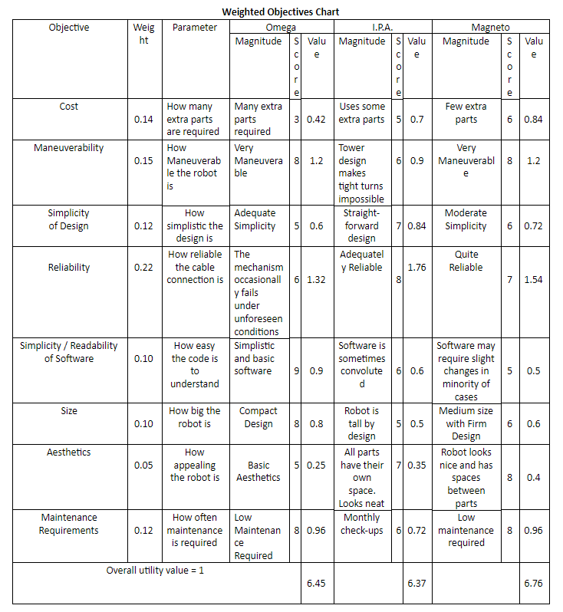

The weighted objectives chart seen in Table 1.0. uses many criteria to determine which design is the most suitable and feasible for Oceans Network Canada.

7

## 3.1 Reliability

The reliability was decided to be the most important criteria, which is reflected with it having the highest eight. If the robot is unable to perform the task most of the time, it is not a suitable design. If the robot malfunctions and the cable does not connect, the robot will be stuck at the ocean floor and someone will have to retrieve. This is a concern for the employees who were supposed to be kept safer by the implementation of the robot. An unreliable robot can also lead to many financial problems. If the robot, the cable, or the ocean floor is damaged due to an unforeseen problem it would result in time and money being spent on fixing the damage.

## 3.2 Maneuverability

Another important criterion is maneuverability. The robot must quickly and efficiently locate the beacon and safely approach it. The robot will ultimately have to traverse the ocean floor, so it is a problem if the prototype has trouble travelling on dryland. Like reliability, if the robot is unable to maneuver properly than it may get stuck and require a diver to retrieve it. There is also the concern that the robot will be unable to reach the attachment point and will either get lost or damaged beyond repair.

## 3.3 Other Criteria

Other criteria such as cost, simplicity and maintenance were also considered, but were given a lower weight due to not being critical to the designs success. Finally, the robots aesthetic appeal was considered. It was deemed to be an unimportant factor but was still worth putting on the weighted objectives chart.

# 4. Conclusion

From the weighted objectives chart, all the designs were quite successful in attaching the cable to the target object. Omega’s software outclassed the other two designs. I.P.A’s design is the simplest of all the three designs. However, Magneto had the highest score because of its smooth movement and quickly locating the beacon. To have a successful cable connection, Magneto required fewer extra parts than Omega and I.P.A. Modifications must be made to magneto’s software to ensure greater consistency.

8

# 5. Recommendation

The most suitable design that meets the needs of Ocean Networks Canada is Magneto. Since it has scored the highest on the weighted objectives chart, it best fulfils the objectives of the project. Magneto’s design, cost, maneuverability and consistency makes it a sensible choice for construction.

Therefore, Aperture Robotics recommends that the Ocean Networks Canada pursue the development of the Magneto prototype for a greater consistency of the cable connection mechanism. Aperture Robotics awaits your approval of the Magneto design.

# 

9

# 6. References

[1]. "About Us | Ocean Networks Canada", *Oceannetworks.ca*, 2018. [Online]. Available: http://www.oceannetworks.ca/about-us. [Accessed: 05- Apr- 2018].

[2]. S. Last, *Request for Proposals*. Victoria: University of Victoria, 201

# 

# 

10

# Appendices

## Appendix A - Work Log

|  |  |  |  |  |
| --- | --- | --- | --- | --- |
| **Date** | **Task Description** | **Assigned to** | **Status/Date Completed** | **Total Time Spent** |
| Feb 25 | Discuss Timeline | Whole Team | Feb 25 | 0.5 hrs |
| Feb. 26 | Task Analysis | Whole Team | Feb 26 | 0.5 hrs |
| Mar. 2 | Weighted Objectives Chart | Whole Team | Mar. 28 | 1.5 hrs |
| Mar. 9 | Report Template | Whole Team | Mar. 7 | 1 hrs |
| Mar. 16 | Presentation Template | Whole Team | Mar 14. | 1 hrs |
| Mar. 18 | Omega Description | Connor Buchko | Mar. 18 | 3 hrs |
| Mar 20. | I.P.A. Description | Evan Roubekas | Mar. 20 | 3 hrs |
| Mar 20. | Magneto Description | Aqeel Mozumder | Mar. 20 | 3 hrs |
| Mar. 22 | Comparative Evaluation | Connor Buchko | Mar. 22 | 2 hrs |
| Mar. 23 | Peer Review Guidelines | Whole Team | Mar. 23 | 1 hrs |
| April 2 | Letter of Transmittal and Title Page | Connor Buchko | April 2 | 3 hrs |
| April 5 | Introduction | Evan Roubekas | April 6 | 3 hrs |
| April 5 | Conclusion and Recommendation | Mustafa Wasif | April 5 | 1 hrs |
| April 7 | Final proofreading | Evan Roubekas and Connor Buchko | April 7 | 2 hrs |
| April 8 | Finalize Document | Evan Roubekas and Connor Buchko | April 8 | 2.5 hrs |
|  |  |  |  | TOTAL: 28 hrs |

Table A - Work Log

11

## Appendix B



Table 3.0

12